## **Assignment weeks 1 and 2**

## *To answer all the questions below, you must use Stata (and, specifically, DASP, if requested). Be concise and clear in your answers.*

## *The assignment is divided into three exercises (the points assigned to each exercise are indicated next to each exercise). Please answer (A) directly in this file after each question (Q) and please attach the *.do file (do-file) that you generated. Rename both files as: “Assignment weeks 1-2-3 - Name, Surname”. Please submit this completed file and the *.do through the virtual drop box (boîte de dépôt) in the course portal, no later than Tuesday, February 5 11:59 a.m. (*[*Québec time*](https://www.timeanddate.com/worldclock/converter.html?iso=20190205T165900&p1=189)*).*

## **Exercise 1 (4%)**

Assume that the population is of composed 14 households that live in regions *A, B and C*.

|  |  |  |  |
| --- | --- | --- | --- |
| identifier | region | *income* | hhsize |
| 1 | A | 210 | 4 |
| 2 | A | 450 | 6 |
| 3 | A | 300 | 5 |
| 4 | A | 210 | 3 |
| 5 | B | 560 | 2 |
| 6 | B | 400 | 4 |
| 7 | C | 140 | 4 |
| 8 | C | 250 | 2 |
| 9 | C | 340 | 2 |
| 10 | C | 220 | 2 |
| 11 | C | 360 | 3 |
| 12 | C | 338 | 2 |
| 13 | C | 330 | 3 |
| 14 | C | 336 | 4 |

**Q 1.1:** Using Stata, generate per capita income (*pcinc*).

**A:**

|  |  |  |  |  |
| --- | --- | --- | --- | --- |
| identifier | region | income | hhsize | pcinc |
| 1 | A | 210 | 4 | 52.5 |
| 2 | A | 450 | 6 | 75 |
| 3 | A | 300 | 5 | 60 |
| 4 | A | 210 | 3 | 70 |
| 5 | B | 560 | 2 | 280 |
| 6 | B | 400 | 4 | 100 |
| 7 | C | 140 | 4 | 35 |
| 8 | C | 250 | 2 | 125 |
| 9 | C | 340 | 2 | 170 |
| 10 | C | 220 | 2 | 110 |
| 11 | C | 360 | 3 | 120 |
| 12 | C | 338 | 2 | 169 |
| 13 | C | 330 | 3 | 110 |
| 14 | C | 336 | 4 | 84 |

**Q 1.2:** Using Stata, estimate the average per capita income and the total incomes of our population.

**A:**

|  |  |  |  |  |  |  |
| --- | --- | --- | --- | --- | --- | --- |
| Variable | Obs | Weight | Mean | Std. Dev. | Min | Max |
|  |  |  |  |  |  |  |
| pcinc | 14 | 46 | 96.6087 | 54.7293 | 35 | 280 |

**Q 1.3:** Assume that, the poverty line is equal to 120, generate the variable “per capita poverty gap (*pgap*)”, and then estimate its average (the per capita poverty gap should be normalized by the poverty line).

**A:**

|  |  |  |  |  |  |  |
| --- | --- | --- | --- | --- | --- | --- |
| Variable | Obs | Weight | Mean | Std. Dev. | Min | Max |
|  |  |  |  |  |  |  |
| pgap | 14 | 46 | 0.29058 | 0.242357 | 0 | 0.708333 |

**Q 1.4:** Redo question Q 1.3 using DASP.

**A:**

|  |  |  |  |  |  |
| --- | --- | --- | --- | --- | --- |
| Variable | Estimate | STE | LB | UB | Pov. line |
|  |  |  |  |  |  |
| pcinc | 0.29058 | 0.065337 | 0.149428 | 0.431731 | 120 |

**Q 1.5:** Assume that the purchasing power in region B is higher than that of region A by 15% and that of region C is higher than that of region A by 20%. In the case where the region A is the region of reference, generate the variable (*deflator*) as a price deflator index, and then generate the variable real per capita income (*rpcinc*).

**A:**

|  |  |  |  |  |  |  |  |  |  |
| --- | --- | --- | --- | --- | --- | --- | --- | --- | --- |
| identifier | region | income | hhsize | pcinc | totalincome | pline | pgap | deflator | rpcinc |
| 1 | A | 210 | 4 | 52.5 | 4444 | 120 | 0.5625 | 1 | 52.5 |
| 2 | A | 450 | 6 | 75 | 4444 | 120 | 0.375 | 1 | 75 |
| 3 | A | 300 | 5 | 60 | 4444 | 120 | 0.5 | 1 | 60 |
| 4 | A | 210 | 3 | 70 | 4444 | 120 | 0.416667 | 1 | 70 |
| 5 | B | 560 | 2 | 280 | 4444 | 120 | 0 | 1.15 | 243.4783 |
| 6 | B | 400 | 4 | 100 | 4444 | 120 | 0.166667 | 1.15 | 86.95652 |
| 7 | C | 140 | 4 | 35 | 4444 | 120 | 0.708333 | 1.2 | 29.16667 |
| 8 | C | 250 | 2 | 125 | 4444 | 120 | 0 | 1.2 | 104.1667 |
| 9 | C | 340 | 2 | 170 | 4444 | 120 | 0 | 1.2 | 141.6667 |
| 10 | C | 220 | 2 | 110 | 4444 | 120 | 0.083333 | 1.2 | 91.66666 |
| 11 | C | 360 | 3 | 120 | 4444 | 120 | 0 | 1.2 | 99.99999 |
| 12 | C | 338 | 2 | 169 | 4444 | 120 | 0 | 1.2 | 140.8333 |
| 13 | C | 330 | 3 | 110 | 4444 | 120 | 0.083333 | 1.2 | 91.66666 |
| 14 | C | 336 | 4 | 84 | 4444 | 120 | 0.3 | 1.2 | 70 |

**Q 1.6:** Redo the question 1.3 and 1.4 using the real per capita income when the poverty line is 130.

**A:**

|  |  |  |  |  |  |
| --- | --- | --- | --- | --- | --- |
| Variable | Obs Weight | Mean | Std. Dev. | Min | Max |
|  |  |  |  |  |  |
| pgap2 | 14 46 | 0.387766 | 0.218442 | 0 | 0.775641 |

**Average using DASP**

|  |  |  |  |  |  |
| --- | --- | --- | --- | --- | --- |
| Variable | Estimate | STE | LB | UB | Pov. line |
|  |  |  |  |  |  |
| rpcinc | 0.387766 | 0.056098 | 0.266574 | 0.508958 | 130 |

**Exercise 2 (3%)**

The Bureau of Statistics asks you to construct the variable “adult-equivalent size (*aes*)” to monitor the change in the average well-being between two periods, *t*1 and *t*2. The sample has a panel structure since the same households were selected in each of the two periods (see the table below). Based on the recommendation of experts, the adult-equivalent size is defined as follows:

$aes = 1 + 0.6*\left(na - 1\right)+ 0.4*nc$

## 

where $na$ is the number of adults within the household and $nc$ is the number of children

|  |  |  |  |  |
| --- | --- | --- | --- | --- |
| *identifier* | *period* | *income* | *hhsize* | $$na$$ |
| 1 | 1 | 29 | 4 | 2 |
| 2 | 1 | 50 | 3 | 2 |
| 3 | 1 | 36 | 4 | 3 |
| 1 | 2 | 30 | 4 | 2 |
| 2 | 2 | 48 | 3 | 3 |
| 3 | 2 | 46 | 5 | 2 |

**Q 2.1:** Using Stata, estimate the average per capita income and the average per adult-equivalent income for each period.

**A:**

* The average per capita income for period 1(a)

|  |  |  |  |  |  |  |
| --- | --- | --- | --- | --- | --- | --- |
| Variable | Obs | Weight | Mean | Std. Dev. | Min | Max |
|  |  |  |  |  |  |  |
| pcinc | 3 | 11 | 10.45455 | 4.747879 | 7.25 | 16.66667 |

* Average per adult-equivalent income 1(b)

|  |  |  |  |  |  |  |
| --- | --- | --- | --- | --- | --- | --- |
| Variable | Obs | Weight | Mean | Std. Dev. | Min | Max |
|  |  |  |  |  |  |  |
| eainc | 3 | 11 | 16.24709 | 6.628922 | 12.08333 | 25 |

* The average per capita income for period 2(a)

|  |  |  |  |  |  |  |
| --- | --- | --- | --- | --- | --- | --- |
| Variable | Obs | Weight | Mean | Std. Dev. | Min | Max |
|  |  |  |  |  |  |  |
| pcinc | 3 | 12 | 10.33333 | 4.10589 | 7.5 | 16 |

* Average per adult-equivalent income 2(b)

|  |  |  |  |  |  |  |
| --- | --- | --- | --- | --- | --- | --- |
| Variable | Obs | Weight | Mean | Std. Dev. | Min | Max |
|  |  |  |  |  |  |  |
| eainc | 3 | 12 | 16.46645 | 4.313659 | 12.5 | 21.81818 |

**Q 2.2:** Discuss the changes in each measure of well-being.

**A:**

Table 1(a) shows thatthe average per capita income for period 1 is 10.45 while the average of per capita income for period 2 as shown in Table 2(a) is 10.3. This suggests a very slight difference average per capita income between period 1 and period 2, where period 1 is higher.

Table 1(b) shows the average per adult-equivalent income for period 1is 16.25 while the average per adult-equivalent income for period 2 as shown in Table 2(b) is 16.47. The average per capita income for period 2 is higher than that of period 1.

### Exercise 3 (5.5%)

**Q 3.1** Use the data_3.dta data file, and then compute the population size of the sampled households.

**A: * I guess weight variable is missing to compute estimated population size.**

**Q 3.2** Rank the per capita expenditures in ascending order and then generate the variable population share (*ps*) that includes the proportion of the sampled population with corresponding per capita expenditures. Based on this, generate the variable percentiles (*p*) and quantiles (*q*).

**A: (See result of the command that generate ps, p and q)**

**Q 3.3** Draw the cumulative distribution curve (X-Axis: the percentiles and Y-Axis: the corresponding per capita expenditures) (range of percentiles: min=0 and max=0.90).

**A:**

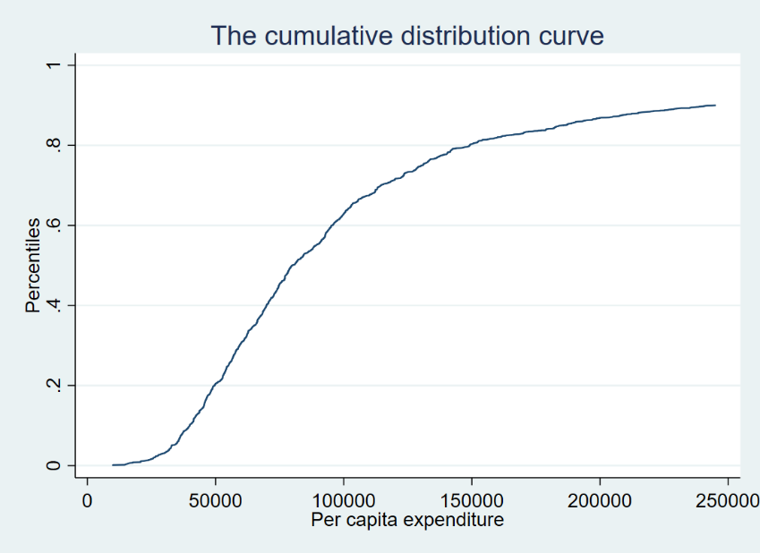

**Q 3.4** Plot the quantile curve (X-axis: percentiles and Y-axis: quantiles) (range of percentiles: min=0 and max=0.90), and briefly discuss the results.

**A:**

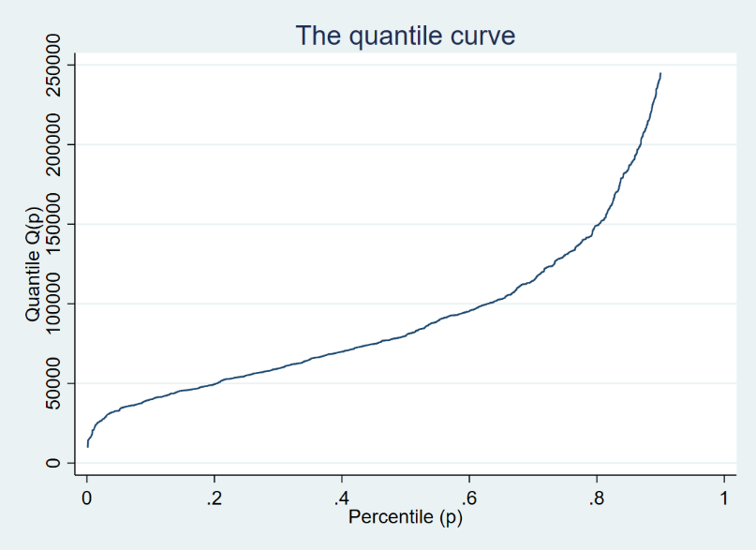

**Q 3.5** Using DASP, draw the quantile curve for each of the rural and urban regions (range of percentiles: min=0 and max=0.90), and briefly discuss the results.

**A:**

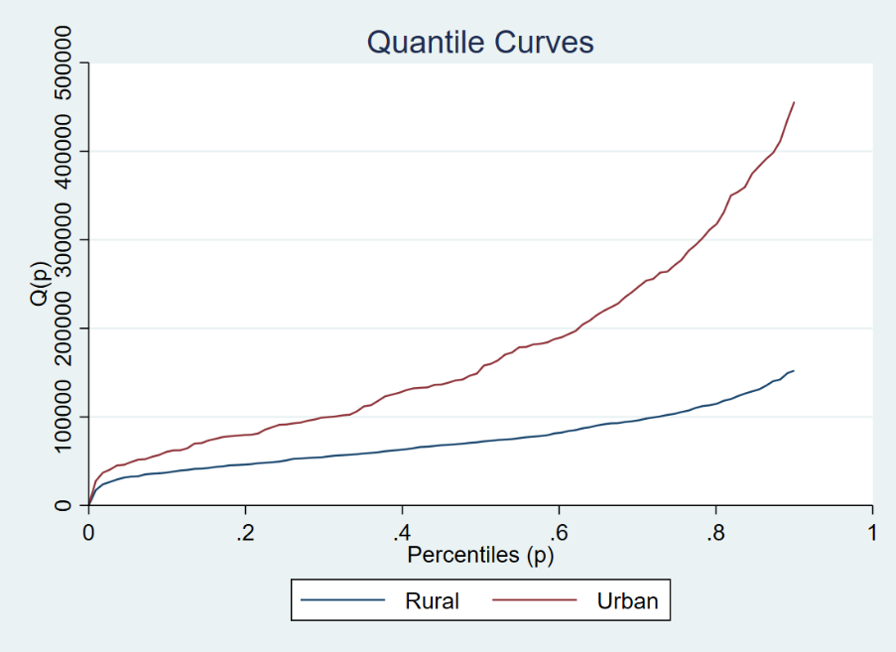

**Q 3.6** Using DASP, draw the density curves of the per capita expenditures by the sex of the household head (range of per capita expenditures: min=0 and max=800000) and briefly discuss the results.

**A:**

